



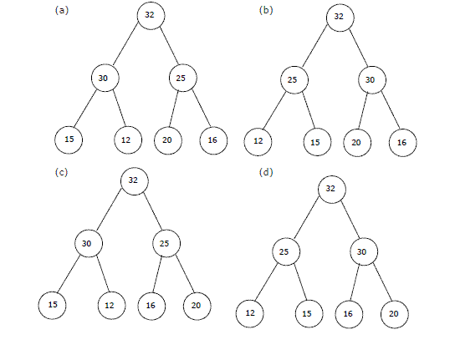

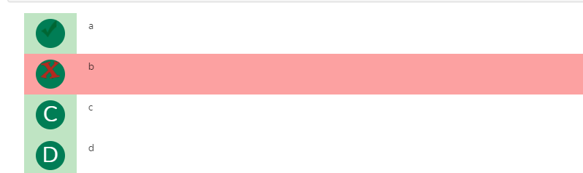

**Explanation**

32, 15, 20, 30, 12, 25, 16

After insertion of 32, 15 and 20

32

/ \

15 20

After insertion of 30

32

/ \

15 20

/

30

Max Heap property is violated, so 30 is swapped with 15

32

/ \

30 20

/

15

After insertion of 12

32

/ \

30 20

/ \

15 12

After insertion of 25

32

/ \

30 20

/ \ /

15 12 25

Max Heap property is violated, so 25 is swapped with 20

32

/ \

30 25

/ \ /

15 12 20

After insertion of 16

32

/ \

30 25

/ \ / \

15 12 20 16